**eBook: Dynamic System Modeling and Control**

[eBook: Dynamic System Modeling and Control (engineeronadisk.com)](http://engineeronadisk.com/book_modeling/rotationa7.html)

* 1. **PRACTICE PROBLEMS**

|  |
| --- |
| 1. Draw the FBDs and write the differential equations for the mechanism below. The   right http://engineeronadisk.com/book_modeling/images/rotation47.gifshaft is fixed in a wall. |

2. For the system pictured below a) write the differential equations (assume small angular deflections) and b) put the equations in state variable form.

|  |
| --- |
| http://engineeronadisk.com/book_modeling/images/rotation67.gif |
| 3. 3. Draw the FBDs and write the differential equations for the mechanism below.  http://engineeronadisk.com/book_modeling/images/rotation60.gif |

4. The system below consists of two masses hanging by a cable over mass `J'. There is a spring in the cable near M2. The cable doesn't slip on `J'.

a) Derive the differential equations for the following system.

|  |
| --- |
| b) Convert the differential equations to state variable equations  http://engineeronadisk.com/book_modeling/images/rotation74.gif |
|  |
| 5. 5.Write the state equations for the system to relate the applied force 'F' to the displacement 'x'. Note that the rotating mass also experiences a rotational damping force indicated with Kd1 http://engineeronadisk.com/book_modeling/images/rotation56.gif | |
| 6. 6. For the system pictured below a) write the differential equations (assume small angular deflections) and b) put the equations in state variable form.http://engineeronadisk.com/book_modeling/images/rotation16.gif | |
| 7. 7. For the system pictured below a) write the differential equations (assume small angular deflections) and b) put the equations in state variable form. | |

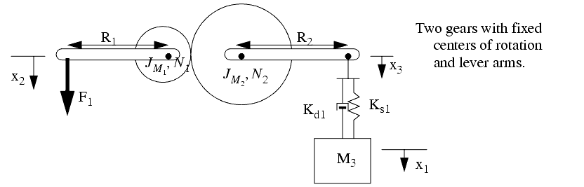

|  |
| --- |
| 8. 8. For the system pictured below a) write the differential equations (assume small angular deflections) and b) put the equations in state variable form.  http://engineeronadisk.com/book_modeling/images/rotation50.gif |

9. For the system pictured below a) write the differential equations (assume small angular deflections) and b) put the equations in state variable form.

|  |
| --- |
| http://engineeronadisk.com/book_modeling/images/rotation4.gif |
| 1010 For the system pictured below a) write the differential equations (assume small angular deflections) and b) put the equations in state variable form http://engineeronadisk.com/book_modeling/images/rotation65.gif |
|  |
| 1111. For the system pictured below a) write the differential equations (assume small angular deflections) and b) put the equations in state variable form. http://engineeronadisk.com/book_modeling/images/rotation71.gif |

12. Find the polar moments of inertia of area and mass for a round cross section with known radius and mass per unit area. How are they related?

13. The rotational spring is connected between a mass `J', and the wall where it is rigidly held. The mass has an applied torque `T', and also experiences damping `B'.

|  |
| --- |
| a) a) Derive the differential equation for the rotational system shown.  b)b) Put the equation in state variable form (using variables) and then plot the position (not velocity) as a function of time for the first 5 seconds with your calculator using the parameters below. Assume the system starts at rest.http://engineeronadisk.com/book_modeling/images/rotation64.gif |
| c) c) A differential equation for the rotating mass with a spring and damper is given below. Solve the differential equation to get a function of time. Assume the system starts at rest.http://engineeronadisk.com/book_modeling/images/rotation72.gif |

14. Find the response as a function of time (i.e. solve the differential equation to get a function of time.). Assume the system starts undeflected and at rest.

|  |
| --- |
| http://engineeronadisk.com/book_modeling/images/rotation22.gif |

15. For the system pictured below a) write the differential equation for the system with theta2 as the output (assume small angular deflections) and b) put the equations in state variable form.

|  |
| --- |
| http://engineeronadisk.com/book_modeling/images/rotation70.gif |

16. Analyze the system pictured below assuming the rope remains tight.

|  |
| --- |
| http://engineeronadisk.com/book_modeling/images/rotation26.gif |

a) Draw FBDs and write the differential equations for the individual masses.

b) Write the equations in state variable matrix form.

c) Use Runge-Kutta integration to find the system state after 1 second.

17. Analyze the system pictured below assuming the rope remains tight and gravity acts downwards.

|  |
| --- |
| http://engineeronadisk.com/book_modeling/images/rotationa25.gif |

a) Draw FBDs and write the differential equations for the individual masses.

b) Combine the equations and simplify the equations as much as possible.

c) Write the equations in state variable matrix form.

d) Use Runge-Kutta to find the system state after 1 second.

**eBook: Dynamic System Modeling and Control**

## 5.7 PRACTICE PROBLEM SOLUTIONS

[eBook: Dynamic System Modeling and Control (engineeronadisk.com)](http://engineeronadisk.com/book_modeling/rotationa8.html)

1.

|  |
| --- |
| http://engineeronadisk.com/book_modeling/images/rotation46.gif |

2.

|  |
| --- |
| http://engineeronadisk.com/book_modeling/images/rotation55.gif |

3.

|  |
| --- |
| http://engineeronadisk.com/book_modeling/images/rotation53.gif |

4.

|  |
| --- |
| http://engineeronadisk.com/book_modeling/images/rotation57.gif |
| http://engineeronadisk.com/book_modeling/images/rotation58.gif | |

5.

|  |
| --- |
| http://engineeronadisk.com/book_modeling/images/rotation66.gif |

6.

|  |
| --- |
| http://engineeronadisk.com/book_modeling/images/rotation68.gif |

7.

|  |
| --- |
| http://engineeronadisk.com/book_modeling/images/rotation69.gif |

8.

|  |
| --- |
| http://engineeronadisk.com/book_modeling/images/rotation75.gif |

9.

|  |
| --- |
| http://engineeronadisk.com/book_modeling/images/rotationa.gif |

10.

|  |
| --- |
| http://engineeronadisk.com/book_modeling/images/rotation41.gif |

11.

|  |
| --- |
| http://engineeronadisk.com/book_modeling/images/rotation52.gif |

12.

|  |
| --- |
| http://engineeronadisk.com/book_modeling/images/rotation76.gif |

13.

|  |
| --- |
| http://engineeronadisk.com/book_modeling/images/rotation79.gif |

|  |
| --- |
| http://engineeronadisk.com/book_modeling/images/rotation2.gif |

14.

|  |
| --- |
| http://engineeronadisk.com/book_modeling/images/rotation6.gif |

15.

|  |
| --- |
| http://engineeronadisk.com/book_modeling/images/rotation77.gif |

16.

|  |
| --- |
| http://engineeronadisk.com/book_modeling/images/rotation31.gif |

17.

|  |  |
| --- | --- |
| http://engineeronadisk.com/book_modeling/images/rotation32.gif | |
|  |

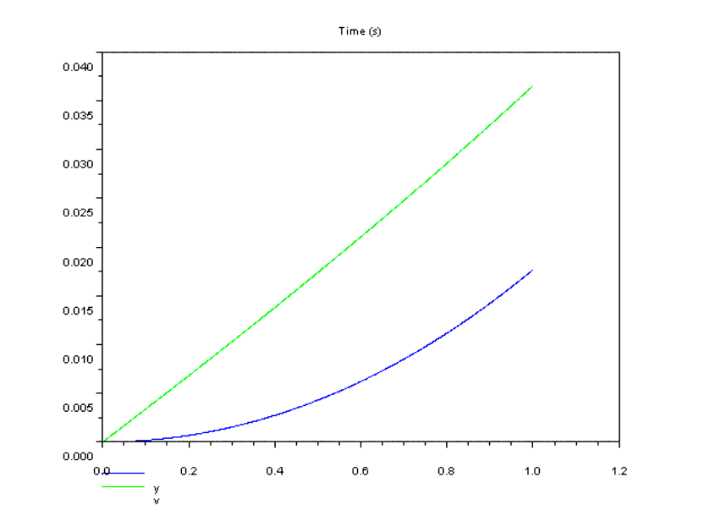

18.

|  |
| --- |
| http://engineeronadisk.com/book_modeling/images/rotationa67.gif |

**eBook: Dynamic System Modeling and Control**

## 5.8 ASSIGNMENT PROBLEMS

## [eBook: Dynamic System Modeling and Control (engineeronadisk.com)](http://engineeronadisk.com/book_modeling/rotationa9.html)

1. Write the state equation(s) for the following mechanical system of two gears. Assume that the cables always remain tight and all deflections are small.

|  |
| --- |
| http://engineeronadisk.com/book_modeling/images/rotation48.gif |

2. Draw FBDs for the following mechanical system containing two gears.

|  |
| --- |
| http://engineeronadisk.com/book_modeling/images/rotation54.gif |

3. Draw FBDs for the following mechanical system. Consider both friction cases.

|  |
| --- |
| http://engineeronadisk.com/book_modeling/images/rotation61.gif |

4. Draw FBDs for the following mechanical system.

|  |
| --- |
| http://engineeronadisk.com/book_modeling/images/rotation62.gif |

5. Develop a differential equation of motion for the system below assuming that the cable always remains tight.

|  |
| --- |
| http://engineeronadisk.com/book_modeling/images/rotation73.gif |

6. Write the state equations for the following mechanical system. Assume that the cables always remain tight and all deflections are small.

|  |
| --- |
| http://engineeronadisk.com/book_modeling/images/rotation78.gif |

7. Write the state equations for the following mechanical system. Assume that the cables always remain tight and all deflections are small.

|  |
| --- |
| http://engineeronadisk.com/book_modeling/images/rotation5.gif |

8. Write the state equations for the following mechanical system. Assume that the cables always remain tight and all deflections are small.

|  |
| --- |
| http://engineeronadisk.com/book_modeling/images/rotation39.gif |

9. A simplified model of a cam shaft driven lever is shown below.

|  |
| --- |
| http://engineeronadisk.com/book_modeling/images/rotationa18.gif |

a) Determine the equation of motion (differential equation) for the system as a function of theta.

b) Assume that L1 = 10.0cm and L2 = 4.0cm. Given an applied force of F=400N resulting in a deflection of y=-1.0cm, calculate the spring coefficient Ks.

c) Explicitly solve the differential equation to find theta as a function of time. The result should be left variable form.

d) Provide the system model as a state variable matrix.

e) Select a value for Jm that results in a natural frequency of 4Hz using the values provided in step b).

**eBook: Dynamic System Modeling and Control**

## 6.7 PRACTICE PROBLEMS

[eBook: Dynamic System Modeling and Control (engineeronadisk.com)](http://engineeronadisk.com/book_modeling/transfera8.html)

1. Develop the input-output equation and transfer function for the mechanical system below. There is viscous damping between the block and the ground. A force is applied to cause the mass to accelerate.

|  |
| --- |
| http://engineeronadisk.com/book_modeling/images/transfer49.gif |

2. Find the input-output form for the following equations.



3. Find the transfer function for the systems below. Here the input is a torque, and the output is the angle of the second mass.

|  |
| --- |
| http://engineeronadisk.com/book_modeling/images/transfer45.gif |

input-output form for the following equations.

|  |
| --- |
| http://engineeronadisk.com/book_modeling/images/transfer8.gif |

5. The following differential equations were converted to the matrix form shown. Use Cramer's rule to find an input-output equation for `y'.

|  |
| --- |
| http://engineeronadisk.com/book_modeling/images/transfer43.gif |

6. Find the input output equation for y2. Ignore the effects of gravity.

|  |  |
| --- | --- |
| http://engineeronadisk.com/book_modeling/images/transfer50.gif |  |

7. Find the input-output equations for the systems below. Here the input is the torque on the left hand side.

|  |
| --- |
| http://engineeronadisk.com/book_modeling/images/transfer32.gif |
|  |

8. Write the input-output equations for the mechanical system below. The input is force `F', and the output is `y' or the angle theta (give both equations). Include the inertia of both masses, and gravity for mass `M'.

|  |
| --- |
| http://engineeronadisk.com/book_modeling/images/transfer18.gif |

|  |
| --- |
| 9. The applied force `F' is the input to the system, and the output is the displacement `x'. http://engineeronadisk.com/book_modeling/images/transfer3.gif |

a) Find x(t), given F(t) = 10N for t >= 0 seconds.

b) Using numerical methods, find the steady-state response for an applied force of F(t) = 10cos(t + 1) N ?

c) Solve the differential equation to find the explicit response for an applied force of F(t) = 10cos(t + 1) N ?

d) Set the acceleration to zero and find an approximate solution for an applied force of F(t) = 10cos(t + 1) N. Compare the solution to the previous solutions.

10. Find the transfer function for the system below.

|  |
| --- |
| http://engineeronadisk.com/book_modeling/images/transfer55.gif |
| 11. For the system below find the a) state and b) input-output equations. The cable always remains tight, and all deflections are small. Assume that the value of J2 is negligible. The input is the force F and the output is the angle `theta'. http://engineeronadisk.com/book_modeling/images/transfer17.gif | |

12. Find the input-output equations for the differential equations below if both 'x' and 'y' are outputs.

|  |
| --- |
| http://engineeronadisk.com/book_modeling/images/transfer37.gif |

13. For the system pictured below find the input-output equation for y2.

|  |
| --- |
| http://engineeronadisk.com/book_modeling/images/transfer40.gif |